Letter to Newcastle City Council:
Dear Councilor-
I’m writing on behalf of Newcastle Trails to ask your help in delaying, mitigating, and possibly avoiding the planned logging of a wooded tract adjacent to Cougar Mountain Park. The tract includes the DeLeo Wall; logging it would impact three trails, including the DeLeo Wall Trail. NT members have contacted us with a number of concerns: losing trails, trees, and views; fire danger; erosion and watershed damage (see www.savedeleowall.org).
Time is critical: Logging may start soon after May 1. A pause is needed. Perhaps the City can ask the DNR for a 30-day moratorium, allowing enough time to gather information and review possibilities for mitigation.
Ideally, a conservation organization (e.g. Forterra, Trust for Public Land) could be recruited to buy or option the tract, making time for interested parties (Newcastle, Renton, King County, Washington State) to find funds or grants for a final purchase, adding the land to Cougar Mountain Park. (Newcastle and Renton are both signatories to the May Creek Basin Plan: logging may impact the basin.)
As the attachment shows (Figure 1), the DeLeo Wall area is the destination of Newcastle’s most important trails, the CrossTown Trail and May Creek Greenway (dark & light green). They enter Cougar Mountain Park on a shared route to join (a) the DeLeo Wall Trail (solid black line) and (b) the Viewpoint Trail (dashed line), which approximates the original DeLeo Wall Trail. Figure 2 shows how these two trails, and (c) the Cougar Access Trail, will be impacted if the tract (shown in red) is clearcut.
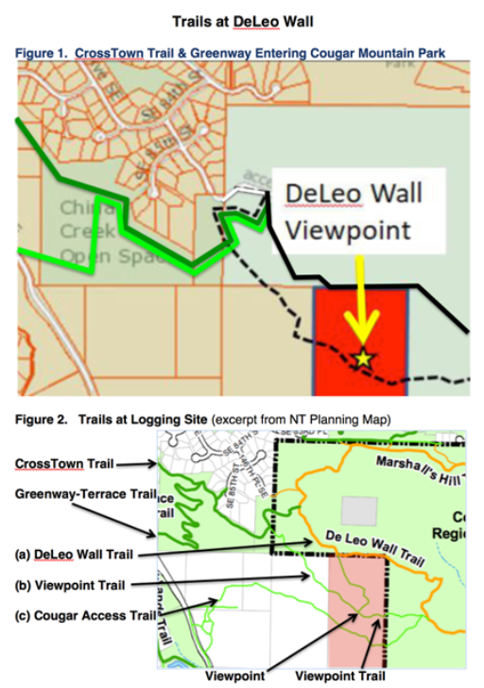
Thank you,
Garry Kampen, president
Newcastle Trails
www.newcastletrails.org
425-271-6181

